Assignment 1 – Jenkins
Task – Host a website on the Jenkins Master server
Steps taken to accomplish the task –
- Launch an ec2 instance
- Install Java-17
- Download and install the Apache Tomcat 10 server
- Download the Jenkins’ war file in the webapps directory of Tomcat server
- Start the tomcat server from the bin >> startup.sh
- Fetch the password from secrets >> initialAdminPassword to configure Jenkins
- Screenshots of the Jenkins Process

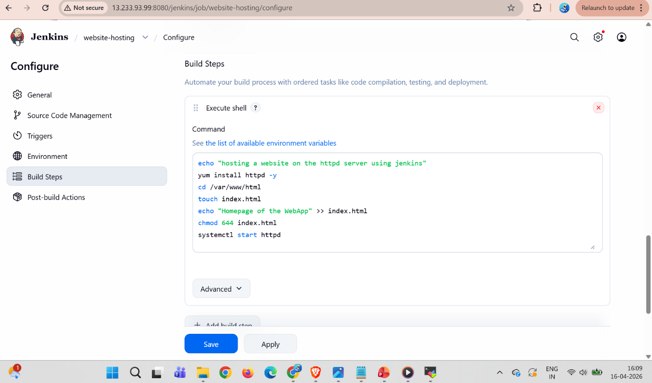
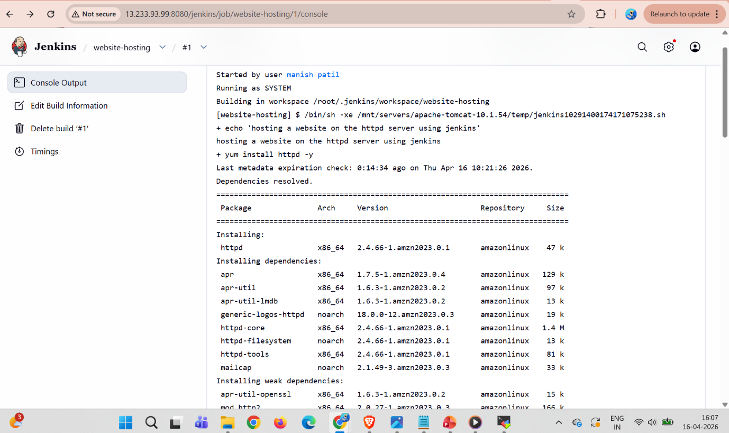
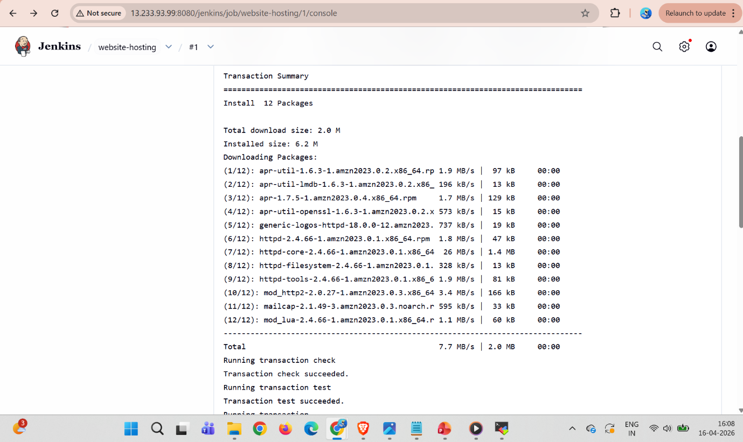
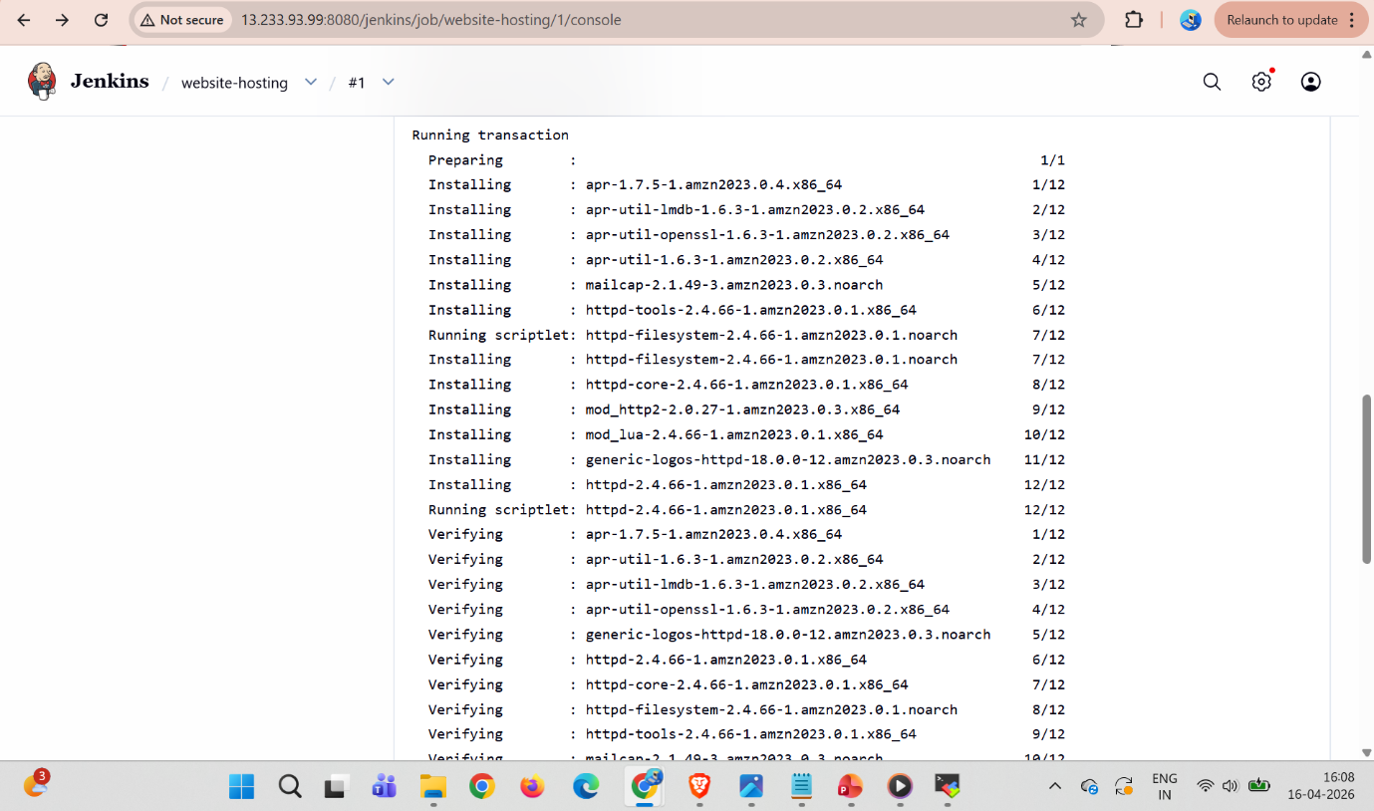
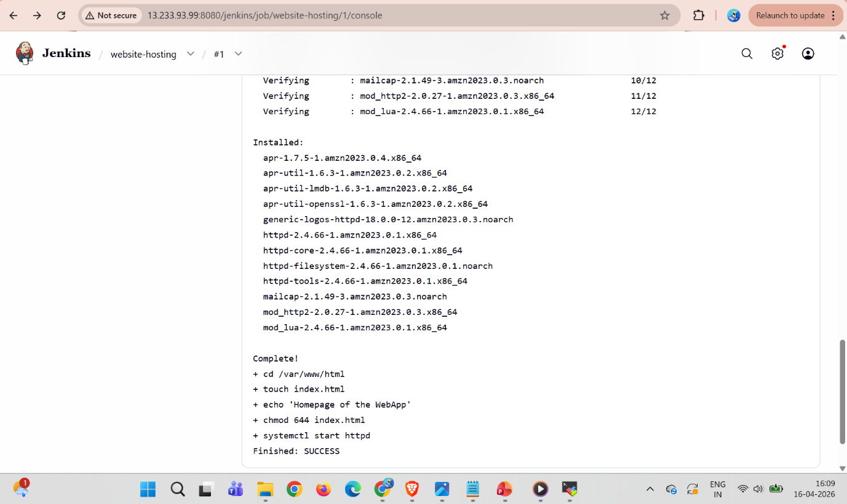
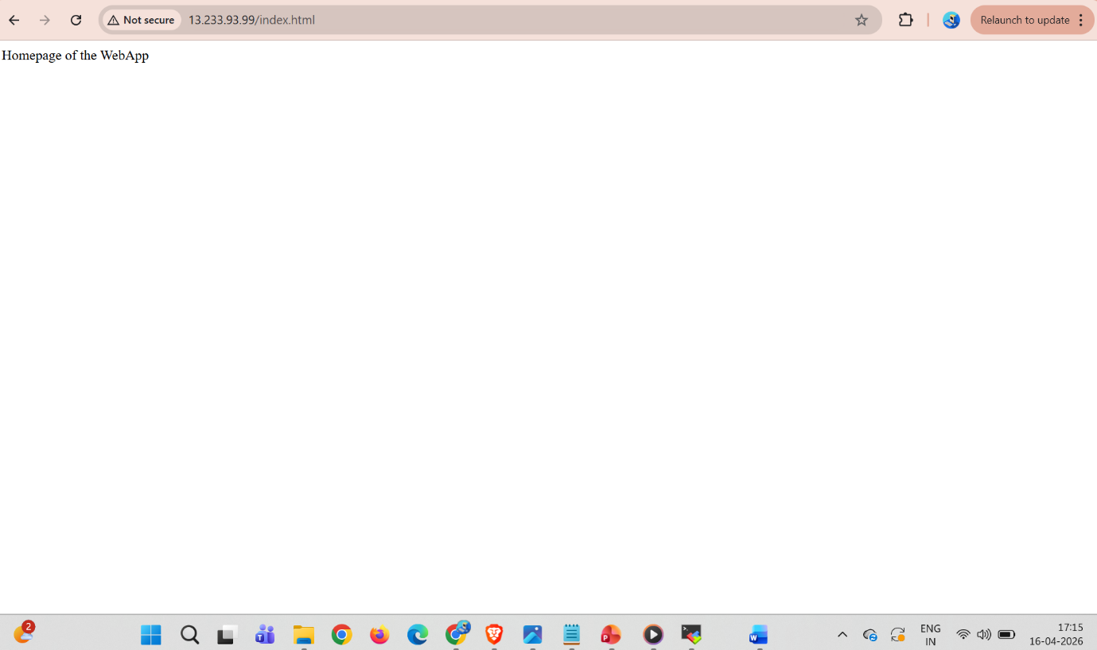

- Commands used:
1 yum list java-17*
2 yum install java-17-amazon-corretto.x86_64
3 cd /mnt
4 ls -ltr
5 mkdir servers
6 cd servers
7 wget https://dlcdn.apache.org/tomcat/tomcat-10/v10.1.54/bin/apache-tomcat-10.1.54.zip
8 ls -ltr
9 unzip apache-tomcat-10.1.54.zip
10 rm -rf apache-tomcat-10.1.54.zip
11 ls -ltr
12 chmod -R 777 apache-tomcat-10.1.54/
13 cd apache-tomcat-10.1.54/
14 ls -ltr
15 cd webapps
16 ls -ltr
17 wget https://get.jenkins.io/war-stable/2.541.3/jenkins.war
18 cd ..
19 ls -ltr
20 cd bn
21 cd bin
22 ls -ltr
23 ./startup.sh
24 cd ..
25 ls -ltr
26 cd logs
27 ls -ltr
28 tail -100f catalina.out
29 cd /root
30 cd .jenkins
31 ls -ltr
32 cd secrets/
33 ls -ltr
34 cat initialAdminPassword

